

**Year 12 Human Biology**

**Unit 3: Endocrine and Nervous System (5%)**

**TASK 2**

**TYPE:** Test

**CONTENT:** Endocrine and Nervous System

**MARKING KEY**

**Time: 60 mins**

Multiple Choice: 15 marks

Short Answer: 25 marks

Extended Answer: 20 marks

TOTAL 60 MARKS

**Weighting: 5%**

**Do not turn page until instructed to do so**

**Section A: Multiple Choice (20 Marks)**

Answer all questions by placing an X through the most correct answer on the multiple choice answer sheet.

1. Which of the options below is the first place that is involved in the regulation of Thyroxine:

1. Hypothalamus
2. Anterior pituitary
3. Posterior pituitary
4. Thyroid

2. Which of the options below has a primary role in endocrine function?

1. Pituitary, salivary gland, thyroid gland
2. Pancreas, liver, pituitary gland
3. Islets of langerhans, pituitary gland, adrenal gland
4. Parathyroid glands, adrenal glands, kidney.

3. Which of the following is FALSE about the comparison between nervous and hormonal actions of the body?

|  |  |  |
| --- | --- | --- |
|  | **Nervous Action** | **Hormonal action** |
| a) | Impulse electro chemical | Impulse chemical |
| b) | Messenger passed along nerve fibres. | messenger passed by blood stream |
| c) | Response slow and lasting | response fast and short lasting |
| d) | Not concerned with growth and development | Concerned with growth and development |

4. Ovulation is produced by a rise in

1. Luteinising hormone and oestrogen.
2. Luteinising hormone and progesterone.
3. Follicle stimulating hormone and oestrogen.
4. Follicle stimulating hormone and progesterone.

5. The target organ for Follicle Stimulating Hormone (FSH) is the:

1. uterine tube.
2. ovary.
3. uterus.
4. vagina.

6. Which one of the following is correct?

|  |  |  |  |
| --- | --- | --- | --- |
|  | Structure | Sympathetic  Activity | Parasympathetic Activity |
| a) | Urinary bladder | Relaxation | Contraction |
| b) | Salivary glands | Increased secretion | Reduced secretion |
| c) | Liver | Increased glucose uptake | Increased release of glucose |
| d) | Bronchioles of the lung | Constriction | Relaxation |

7. Voluntary muscle movement is controlled by

1. an upper motor neuron in the brainstem and a lower motor neuron in the spinal cord.
2. an upper motor neuron in the cerebrum and a lower motor neuron in the spinal cord.
3. an upper motor neuron in the cerebrum and a lower motor neuron in the dorsal root ganglion.
4. an upper motor neuron in the spinal cord and a lower motor neuron in the skeletal muscle

8. Injury to the hypothalamus may result in all of the following EXCEPT

1. a loss of temperature control.
2. a production of excessive quantities of urine.
3. loss of awareness of body position.
4. a disrupted menstrual cycle.

9. Which of the following is NOT a function of the cerebrospinal fluid?

1. Transfer of neural messages from one part of the brain to another.
2. Aid removal of metabolic wastes and supply of nutrients to nerve tissue.
3. Suspension of the brain in fluid to reduce pressure on particular points.
4. Protection of the central nervous system from mechanical damage.

10. Which statement about nerve fibres is correct?

1. Fibres that have a larger diameter will conduct impulses slower than those with a smaller diameter.
2. Myelinated fibres conduct impulses slower than unmyelinated nerve impulses.
3. Nodes of Ranvier increase the speed of nerve impulse transmission.
4. All myelinated nerve impulses end on skeletal muscles.

11. The spinal cord has white matter

1. inside, grey matter outside.
2. outside, grey matter inside and a ventral motor root.
3. outside, grey matter inside and a dorsal motor root.
4. inside, grey matter outside and a ventral motor root.

12. The somatic division belongs to which component of the peripheral nervous system

1. Afferent
2. Autonomic
3. Efferent
4. Parasympathetic

13. Which of the following is correct?

1. Afferent division carries information into the CNS
2. Efferent division carries information away from the CNS
3. The autonomic division can be responsible for preparing the body for strenuous physical activity
4. All of the above

14. If the sympathetic nerve to the heart was cut, the heart rate would be expected to:

1. increase
2. decrease
3. stay the same
4. increase then decrease

15. Looking at the picture below the synapse is labelled:

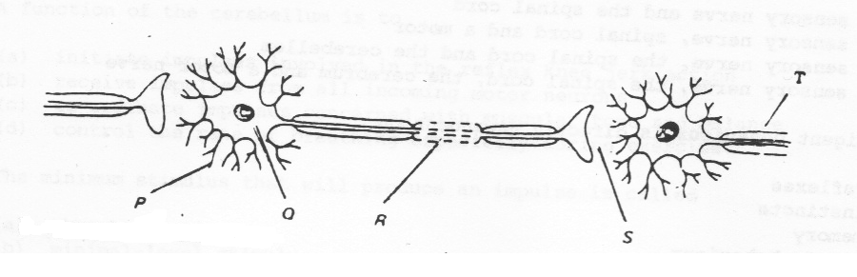

1. P
2. Q
3. R
4. S

**END OF SECTION A**

Name _________________________________________

Teacher_________________________________________

**ASHDALE SECONDARY COLLEGE**

**Human Biological Science**

**Unit 3 & 4**

**TASK 3 – Test 1**

**Endocrine & Nervous System**

TOTAL 60 MARKS

**Multiple Choice Answer Booklet**

Answer all questions by placing an X through the correct answer

|  |  |  |  |  |  |  |  |  |  |  |
| --- | --- | --- | --- | --- | --- | --- | --- | --- | --- | --- |
| **1** | A | B | C | D |  | **11** | A | B | C | D |
| **2** | A | B | C | D |  | **12** | A | B | C | D |
| **3** | A | B | C | D |  | **13** | A | B | C | D |
| **4** | A | B | C | D |  | **14** | A | B | C | D |
| **5** | A | B | C | D |  | **15** | A | B | C | D |
| **6** | A | B | C | D |  |  |  |  |  |  |
| **7** | A | B | C | D |  |  |  |  |  |  |
| **8** | A | B | C | D |  |  |  |  |  |  |
| **9** | A | B | C | D |  |  |  |  |  |  |
| **10** | A | B | C | D |  |  |  |  |  |  |

**Section B: Short Answer (30 Marks)**

Answer all questions in the spaces provided.

**Question 16 (6 Marks)**

The diagram below refers to parts (a) through (c) of question 1

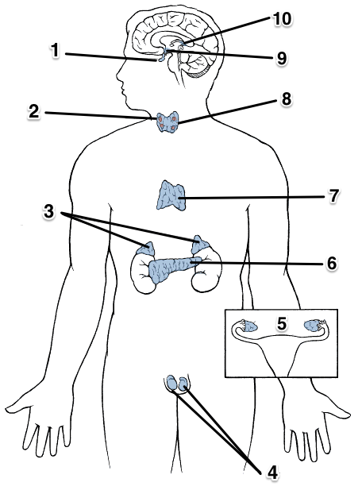

a) Describe how structure 1 will have an effect on the release of hormones from structure 3. (2 marks)

|  |  |
| --- | --- |
| **Describe** | **Marks** |
| ANTERIOR PITUITARY releases Adrenocorticotropic Hormone (ACTH) | 1 |
| Which acts on the ADRENAL CORTEX to stimulate the production of aldosterone/cortisol/testosterone (or overall category name) | 1 |

b) Describe the impact structure 9 has on the endocrine system? Provide an example to support your response. (2 marks)

|  |  |
| --- | --- |
| **Describe** | **Marks** |
| Production of releasing/inhibiting factors/hormones that influence the ANTERIOR PITUITARY gland to release hormones  OR nervous impulse to influence the release of hormones from POSTERIOR PITUITARY | 1 |
| Any example (1) – eg hypothalamus releases TSHrf to stimulate the Pituitary to release TSH, which will in turn stimulate the Thyroid gland to release Thyroxine | 1 |

c) If structure 6 was badly damaged, list the hormone(s) which would be affected. (2 marks)

|  |  |
| --- | --- |
| **List** | **Marks** |
| Glucagon | 1 |
| Insulin | 1 |

**Question 17 (4 Marks)**

A boy was asked to speak, on behalf of the student body, at his year 12 Graduation ceremony. Prior to his speech, he felt extremely nervous.

1. Name the specific division of his nervous system would have contributed to his condition. (1 mark)

|  |  |
| --- | --- |
| **Name** | **Marks** |
| Sympathetic Nervous System | 1 |

If ANS or Efferent no marks (not specific enough)

1. Name the hormone(s) which would have been involved in this process.

(1 mark)

|  |  |
| --- | --- |
| **List** | **Marks** |
| Adrenaline/Noradrenaline | 1 |

1. Name where this hormone(s) are released from. (1 mark)

|  |  |
| --- | --- |
| **Describe** | **Marks** |
| Adrenal medulla | 1 |

1. Compare the actions of nerves and hormones in regard to the specificity of their actions. (1 mark)

|  |  |
| --- | --- |
| **Compare** | **Marks** |
| Hormones:Non-specific/can affect a few or many body parts  Nerves:Specific/affects target cells or organs | 1 |

Must include a comparison of both.

**Question 18 (3 marks)**

The diagram below represents the transmission of a nerve impulse down an axon.



A B C

A B C

A B C

Name and identify the charge at each phase of the nerve impulse represented by the bands labelled A, B, and C. (3 marks)

|  |  |
| --- | --- |
| **Outline** | **Marks** |
| A: Resting membrane potential/Polarised -70mV | 1 |
| B: Refractory/repolarisation/hyperpolatisation period -80mV | 1 |
| C: depolarisation /action potential +30mV | 1 |

**Question 19 (4 marks)**

Picture A

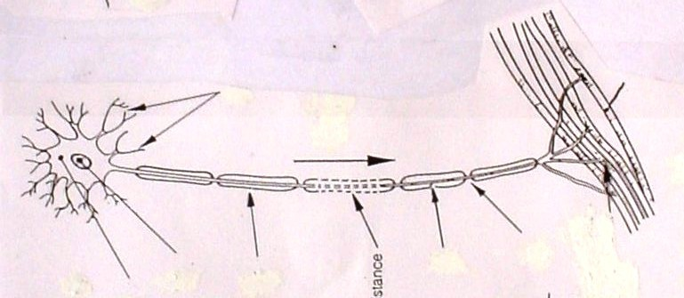

a) Classify the neuron in picture A according to its structure and function

(2 marks)

Structure: **Multipolar neuron (1)**

Function: **Motor/efferent neuron (1)**

Must have this, if both on one line do not award any marks for this.

b) Features on this neuron allow transmission of an electrical impulse at a speed of up to 140 metres/second. Explain the reasons why the impulse is able to travel at this speed.

(2 marks)

|  |  |
| --- | --- |
| **Explain** | **Marks** |
| Myelin sheath allows for fast conduction | 1 |
| Impulse jumps from one Node of Ranvier to the next | 1 |

**Question 20 (8 marks)**

Complete the table below to show the site of production, hormone produced, target organs and effect of the hormones associated with various endocrine glands in the human body.

(8 marks)

|  |  |  |  |
| --- | --- | --- | --- |
| **Production site** | **Hormone produced** | **Target organ/s** | **Effect** |
| Anterior Pituitary | **Prolactin** | Breast Tissue | **Stimulates development of breasts OR Initiates/maintains/Regulates milk production** |
| **Pancreas** | **Insulin**  **or**  **glucagon** | Liver | **Decreases blood glucose**  **Or**  **Increases blood glucose** |
| **Thymus** | **Thymosins** | T-Lymphocytes | **Maturation/ development/ production of disease fighting cells**  **(T-lymphocytes)** |

**END OF SECTION B**

**Section C: Extended Answer (20 Marks)**

Answer all parts of ALL questions on the lines provided.

**Question 21**

Fiona, a very excitable young girl, was walking along a busy street talking intensely on her mobile phone to her best friend. She was so focused on her conversation that, without thinking, she stepped onto the road and was immediately startled by the screeching of tyres and the blaring sound of a very loud horn. When she realised that she had stepped in front of a car but had not been run over, she felt greatly relieved but noticed that her body had responded in several different ways.

a) Identify three (3) responses that Fiona’s body would automatically demonstrate in her reaction to danger and explain how each is useful in this situation. (6 marks)

**Any 3 responses plus 3 explanations**

|  |  |
| --- | --- |
| **Identify** | **Explain Usefulness** |
| heart rate to accelerate/increase (1) | to increase supply of blood (oxygen and glucose) to provide energy to priority areas (1) |
| blood vessels to the muscles to dilate (1) | to pass more oxygen and glucose to muscles for quick movement (1) |
| to increase the supply of blood to the muscles (1)  OR to increase blood distribution to the skeletal muscles (1) | in case movement is required (1)  OR to increase supply of nutrients to allow for quick movements (1) |
| to increase the blood volume to the brain (1) | to supply increased nutrients to improve response and perception by the brain (1) |
| pupils to dilate (1) | to improve peripheral vision/lets more light in to see what is coming and what is happening (1) |
| the airways in the lungs to dilate/breathing rate increases (1) | to improve flow of air into and out of the lungs to improve supply and removal of gases (1) |
| release of adrenaline/noradrenaline from adrenal (medulla) (1) | to carry out the fight or flight response (1) |
| adrenaline/noradrenaline raises blood glucose levels (1) | to supply more glucose/energy to muscles for quick movement (1) |
| Increases secretion of sweat (1) | to cool down the body (1) |
| Vasoconstriction of blood vessels to digestive system (1) | allow more blood to be redistributed to muscles to allow for rapid movement (1) |

1. Cortisol is a steroid hormone. Describe the mode of action of this hormone on a cell. (3 marks)

|  |  |
| --- | --- |
| **Description – any 3 of the following** | Marks |
| * Steriod hormones are “Lipophilic”/dissolve in fats - not water, and so can move straight through the membrane. * Combines with a receptor inside the cell. * Receptor may be on mitochondria/other organelles/nucleus/cytosol * Hormone-receptor complex binds to hormone-response element (HRE) on DNA * Activates the DNA/genes controlling the formation of proteins/carries out particular function. OR specific function of cortisol ie. Increase blood glucose | Any 3 |

**Question 22**

The Chemical Weapons Convention was agreed upon in 1997 which prevents the use of chemical weapons to deliberately harm another person. Today, 192 countries are under this treaty which is now international law.

On March 4 2019, former Russian spy Sergei Skripal, his daughter Yulia were exposed to Novichok (a nerve agent) in England. This nerve agent acts to inhibit the enzyme which breaks down neurotransmitters at synapses in the cental and peripheral nervous systems.

1. Describe what happens when a neurotransmitter is not removed from the synapse.

(3 marks)

|  |  |
| --- | --- |
| **Description – any 3 of the following** | Marks |
| * Neurotransmitter builds up in the cleft * Nerve transmission more likely/saturation of receptors on post-synaptic membrane * Can cause rapid muscle contraction/spasms * Loss of motor control   NOT suitable to just state “leads to death” must provide reason for this.  Ie. Can lead to respiratory paralysis (in extreme cases) and loss of oxygen in heart and other vital organs | 3 |

1. Using the somatic nervous system as an example, describe how a nerve impulse travels across a synapse to the effector.

(5 marks)

|  |  |
| --- | --- |
| **Description – any 5 of the following** | Marks |
| * Action potential opens calcium channels in the membrane of the **motor neuron** (axon termials) * Calcium flows into the pre-synaptic cell. * Vesicles containing the neurotransmitter **acetylcholine** move towards the pre-synaptic membrane. * Vesicles fuse with the cell membrane, releasing their contents into the synaptic cleft by exocytosis. * The neurotransmitter (acetylcholine) diffuses across the synaptic cleft * Act on the post-synaptic **muscle** cell by binding to specific receptorson the cell surface. * Depolarisation of post-synaptic cell (Na+ channels open). * Neutrotransmitter (acetylcholine)removed after impulse is gone.   Students MUST include the bolded terms to get those marks | 5 |

1. Action potentials are described as ‘all or none responses’. However, it is possible for you to detect the difference between a sheet of paper and a brick being dropped on your foot. Explain why.

(3 marks)

|  |  |
| --- | --- |
| **Description – any 3 of the following** | Marks |
| * Action potential remains the same/ nerve impulse is not more intense or weaker * More action potentials are created in a time frame/ increase frequency of action potentials * More neurons stimulated/ more pain receptors stimulated * Cerebrum processes the increased number of action potentials * Become conscious of a greater degree of pain/ more pain detected | 3 |